Lab 1: Bouncing Balls
In this lab, you will investigate the dynamics of how golf balls bounce when released from different distances. The purpose for this lab is to have you examine all aspects of the modeling process from observation through publication.

Goals:
- Measure the number of times golf balls bounce from different heights
- Fit a linear regression to the phenomena
- Integrate your data with others data and update the model
- Evaluate the models

Required Equipment:
- Measuring tape or yard stick
- Golf ball
- Computer with MS-Excel
________________________________________________________________________

1. Setup
It has been observed that the number of times a golf ball bounces is dependent upon the height from which it was dropped. My theory is that the number of bounces is linearly related to the height the ball was dropped.

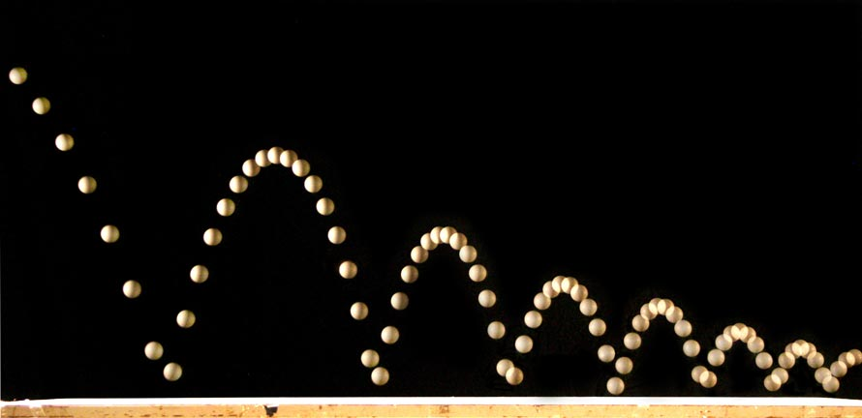
Figure 1. View of a ball bouncing (people.rit.edu)

2. Measuring Bouncing Balls
Divide into groups of two or three. Decide on a protocol within your group for how you will be measuring the number of times a golf ball bounces given it is dropped from different distances. Record the distances and number of times the ball bounces until you feel you have enough data.

3. Modeling
Bring the data into Excel and fit a linear regression model to the data.

4. Collect Data from the Other Groups
If there is no GoogleDrive folder for this lab, create it and add your group’s data to the folder. Fit another linear equation to a data set with all the available data.

Answer the following questions:
1. How did your first model perform?
2. How did the model with integrated data perform?
3. Which model do you feel is “best” and why?
4. Is the theory correct or not? Justify your answer and provide a discussion based on a few references (you don’t have to provide a full background literature search, just a few references and web pages from credible sources are fine).

